**Assignment Report: Multi-Class Image Classification**

**Fullname:** Dang Khoa Le

**Student ID:** 103844421

**Tutorial:** Monday 6.30-8.30 PM

**1 Methodology**

This project focuses on developing and evaluating deep learning models, in consist of:

+ Base CNN model built from scratch

+ CNN model with dropouts and augmentation

+ ResNet50 transfer learning model

These models are deployed for multi-class image classification task using dataset **"Deep Learning Practice - Image Classification"** from Kaggle, where each class contains 1000 images (total of 10,000). The dataset includes 10 distinct image classes, and the model must generalize to classify unseen samples.

**1.1 Dataset and Preprocessing**

The dataset, stored in Google Drive under the train/ directory, contains 10 subfolders—each representing a distinct class—with 1,000 images per class. Since the dataset does not include a separate testing set, I manually split the data into training and validation sets using an 80/20 ratio while preserving class distribution through stratified sampling:

train_paths, val_paths, train_labels, val_labels = train_test_split(

file_paths, labels, test_size=0.2, stratify=labels, random_state=SEED)

Before feeding images into the models training sessions, several preprocessing steps were applied using TensorFlow’s ImageDataGenerator. These include resizing, scaling, augmentation, and batching, ensuring consistency and variability during training.

from tensorflow.keras.preprocessing.image import ImageDataGenerator

**Label Extraction and Path Construction**

* Each image was mapped to its corresponding class name based on its folder.
* This generated a list of file paths (file_paths) and associated class labels (labels).

for class_index, class_name in enumerate(class_names):

class_folder = os.path.join(train_path, class_name)

for fname in os.listdir(class_folder):

file_paths.append(os.path.join(class_folder, fname))

labels.append(class_name)

* + 1. **CNN Models’ Processing**

**Input Size:** 128x128.

**Normalization:**

* All pixel values were rescaled from [0, 255] to [0, 1] by dividing by 255.
* Normalization helps the model converge faster during training by standardizing the input range.

**Data Augmentation (Training Set Only):** To reduce overfitting and improve generalization, the training data was augmented with the following techniques:

* **Horizontal Flipping**: Randomly flips images left-to-right.
* **Rotation**: Rotates images randomly up to 20 degrees.
* **Zooming**: Applies random zoom with a range of 20%.

train_gen = ImageDataGenerator(rescale=1./255, horizontal_flip=True, rotation_range=20, zoom_range=0.2)

* + 1. **ResNet50 Model Processing**

**Input Size:** 224×224

**Normalization:** Used keras.applications.resnet50.preprocess_input to match ImageNet expectations.

from tensorflow.keras.applications.resnet50 import preprocess_input

r50_val_gen = ImageDataGenerator(preprocessing_function=preprocess_input)

r50_train_gen = ImageDataGenerator(preprocessing_function=preprocess_input)

**Data Augmentations:** Not applied initially to keep baseline consistent.

**1.2 Model Architectures**

I implemented and evaluated two CNN architectures:

**Model 1: Baseline CNN**

* 2 Convolutional layers with ReLU
* 2 MaxPooling layers
* Flatten → Dense(128) → Dense(output)
* Output: Softmax for 10 classes

model = tf.keras.Sequential([

tf.keras.layers.Conv2D(32, (3,3), activation='relu', input_shape=(*IMG_SIZE, 3)),

tf.keras.layers.MaxPooling2D(2, 2),

tf.keras.layers.Conv2D(64, (3,3), activation='relu'),

tf.keras.layers.MaxPooling2D(2, 2),

tf.keras.layers.Flatten(),

tf.keras.layers.Dense(128, activation='relu'),

tf.keras.layers.Dense(num_classes, activation='softmax')

])

model.compile(optimizer='adam',

loss='categorical_crossentropy',

metrics=['accuracy'])

**Model 2: CNN + Dropout + Augmentation**

* Similar to Model 1, but includes:
  + **Dropout(0.3)** after second conv block
  + **Dropout(0.5)** before final dense layer
* Data augmentation improves robustness
* Dropout mitigates overfitting
* Also applying data augmentation

model = tf.keras.Sequential([

tf.keras.layers.Conv2D(32, (3,3), activation='relu', input_shape=(*IMG_SIZE, 3)),

tf.keras.layers.MaxPooling2D(2, 2),

tf.keras.layers.Conv2D(64, (3,3), activation='relu'),

tf.keras.layers.MaxPooling2D(2, 2),

tf.keras.layers.Dropout(0.3),

tf.keras.layers.Flatten(),

tf.keras.layers.Dense(256, activation='relu'),

tf.keras.layers.Dropout(0.5),

tf.keras.layers.Dense(num_classes, activation='softmax')

])

model.compile(optimizer='adam',

loss='categorical_crossentropy',

metrics=['accuracy'])

**Model 3: ResNet50 + Transfer Learning**

* Architecture:
  + Frozen base: *ResNet50(include_top=False, weights='imagenet')*
  + Custom classifier head:
    - GlobalAveragePooling2D
    - Dense(128, relu)
    - Dropout(0.5)
    - Dense(10, softmax)
* Optimizer: Adam (learning rate = 1e-4)

def build_resnet50_transfer():

r50_model = ResNet50(weights='imagenet', include_top=False, input_shape=(*IMG_SIZE_R50, 3))

r50_model.trainable = False # Freeze base

x = r50_model.output

x = GlobalAveragePooling2D()(x)

x = Dropout(0.5)(x)

x = Dense(128, activation='relu')(x)

x = Dropout(0.3)(x)

predictions = Dense(num_classes, activation='softmax')(x)

model = Model(inputs=r50_model.input, outputs=predictions)

model.compile(optimizer=Adam(learning_rate=1e-4), loss='categorical_crossentropy', metrics=['accuracy'])

return model

**1.3 Training Details**

* **Loss**: categorical_crossentropy (for multi-class)
* **Optimizer**: adam
* **Epochs**: 20
* **Batch Size**: 32
* **Validation**: 20% of val_data splitted

history_base = model_base.fit(train_data, epochs=20, validation_data=val_data)

history_augmentation = model_augmentation.fit(train_data, epochs=20, validation_data=val_data)

**1.4 Model Shapes**

This script was executed to visualize and explain the 3 models’ shape using summary() function:

model_base.summary()

model_augmentation.summary()

model_resnet50.summary()

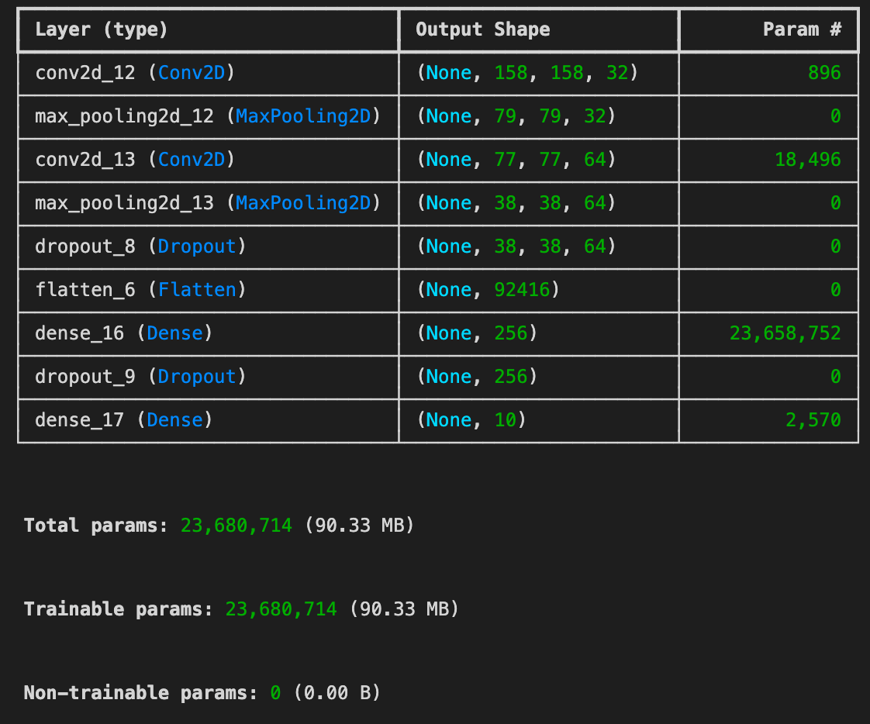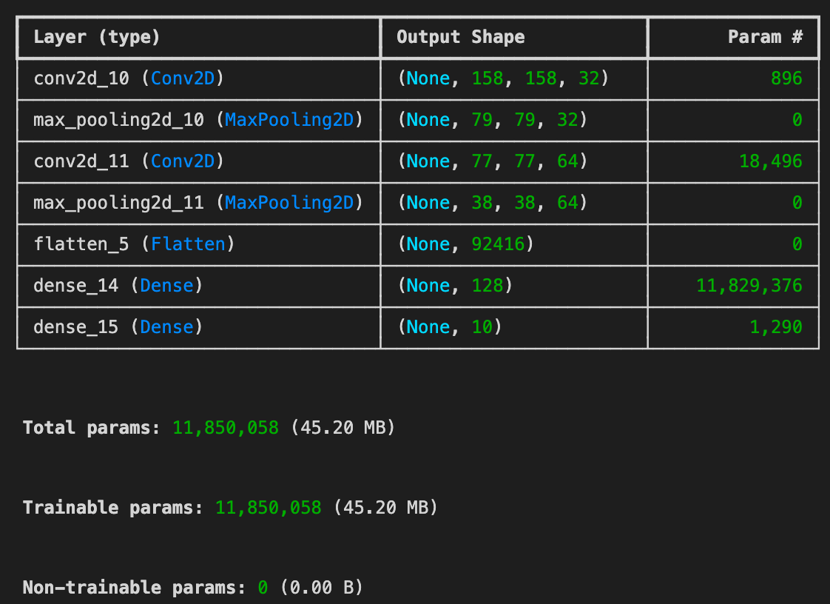Output was shown on console:

Table 1. CNN Baseline Model Shape

**1.4.1. CNN Baseline Model** Table 2. Dropout + Augmentation Model Shape

**Structure Overview:**

* Conv2D → MaxPooling2D → Conv2D → MaxPooling2D → Flatten → Dense(128) → Dense(10)
* Total Parameters: **~11.850 million**

**Detailed Layer Flow:**

* Conv2D(32 filters, 3x3 kernel): The first convolution layer extracts low-level features like edges and textures from input images (size reduces slightly).
* MaxPooling2D(2x2): Down-samples the feature maps to reduce dimensionality and computation.
* Conv2D(64 filters, 3x3 kernel): Learns more complex features by combining basic patterns.
* MaxPooling2D(2x2): Further down-samples feature maps.
* Flatten(): Flattens the 3D output to a 1D vector for the fully connected layers.
* Dense(128): A fully connected layer with 128 neurons for feature interpretation.
* Dense(10): Output layer predicting probabilities for 10 classes (SoftMax activation).

**1.4.2. CNN with Dropout and Augmentation Model**

**Structure Overview:**

* Conv2D → MaxPooling2D → Conv2D → MaxPooling2D → Dropout → Flatten → Dense(256) → Dropout → Dense(10)
* Total Parameters: **~23.681 million**

**Detailed Layer Flow:**

* Similar to the baseline, but with the following additions:
* Dropout(0.3 after conv layers):
  + Introduces random neuron deactivation during training.
  + Reduces the risk of overfitting.
* Dense(256):
  + Increased number of neurons to **learn more complex patterns**.
* Dropout(0.5 after Dense):
  + Further regularizes the model.

**1.4.3. Transfer Learning with ResNet50 Model**

**Structure Overview:**

* Pretrained ResNet50 Base (Frozen) → GlobalAveragePooling → Dropout(0.5) → Dense(128) → Dropout(0.3) → Dense(10)
* Total Parameters: **~23.851 million**
  + Trainable params: **~263K** (only the top layers)
  + Non-trainable params: **~23.858M** (ResNet50 frozen)

**Detailed Layer Flow:**

* ResNet50 base (Frozen):
  + Pretrained on ImageNet.
  + Extracts highly generalized image features such as textures, patterns, object parts.
  + No training on lower layers; only new layers are trained.
* GlobalAveragePooling2D:
  + Replaces the dense flattening operation to reduce parameters.
  + Reduces the tensor to (None, 2048) by averaging spatial dimensions.
* Dropout(0.5):
  + Reduces overfitting.
* Dense(128, ReLU):
  + Fully connected layer for feature compression and discrimination.
* Dropout(0.3):
  + Extra regularization.
* Dense(10, Softmax):
  + Output layer mapping to the 10 classes.

|  |  |  |
| --- | --- | --- |
| Model | Key Characteristics | Purpose |
| CNN Baseline | Basic ConvNet, no regularization | Provide a reference benchmark |
| CNN + Dropout/Augmentation | Added Dropout and larger Dense layer to improve robustness | Mitigate overfitting and enhance learning |
| ResNet50 Transfer Learning | Pretrained deep network (ResNet50), frozen weights | Leverage large-scale ImageNet features for higher accuracy and faster convergence |

Table 3. Models Shape Summary and Reason of Selection

**2. Results and Discussion**

**2.1 Model per Class Accuracy**

**2.1.1 Methods**

To ensure that the predicted labels align correctly with the ground truth across batch-wise inference, I implemented a synchronized evaluation loop. This custom function extracts predictions and true labels in the exact order of processing:

def get_y_true_and_pred(model, generator):

y_true_all, y_pred_all = [], []

for x_batch, y_batch in generator:

y_true_all.extend(np.argmax(y_batch, axis=1))

y_pred_batch = model.predict(x_batch, verbose=0)

y_pred_all.extend(np.argmax(y_pred_batch, axis=1))

# Stop after full epoch

if len(y_true_all) >= generator.samples:

break

return np.array(y_true_all), np.array(y_pred_all)

This method was applied for all models, ensuring accurate comparison:

* val_data was used for both CNN models,
* r50_val_data was used for ResNet50 with transfer learning.

**2.1.2 Results**

The classification report (precision, recall, and F1-score per class) reveals how each model performs across individual categories. This deeper evaluation is critical to understanding not just overall performance, but also how well the model handles each class — especially important in imbalanced or multi-class datasets like ours.

To generate this breakdown, I used a utility function:

def per_class_accuracy(y_true, y_pred, class_names, model_name="Model"):

report = classification_report(y_true, y_pred, labels=range(len(class_names)), target_names=class_names, output_dict=True, zero_division=0)

# Print the classification report for the current model

print(classification_report(y_true, y_pred, target_names=class_names, digits=4))

print(f"\nPer-Class Accuracy (Recall) for {model_name}:")

for cls in class_names:

acc = report[cls]["recall"]

print(f"{cls:10s}: {acc:.4f}")

Which:

* Generates a full classification report using scikit-learn's classification_report(),
* Extracts and prints the recall (i.e., per-class accuracy) for each class summary.
* Ensures consistent class alignment by explicitly setting the labels and target_names,
* Handles edge cases where a class might not be predicted at all by setting zero_division=0.

**a) Baseline CNN:**

* Best performance: *Plantae* (recall: 0.69), *Mammalia* (0.48), *Aves* (0.49), *Arachnida* (0.41)
* Poor performance: *Reptilia* (0.21), *Mollusca* (0.19), *Amphibia* (0.20)
* Insight: The model relies heavily on simpler texture or structure-based cues, performing better on classes with distinct features but struggling with overlapping features or limited samples.

precision recall f1-score support

Amphibia 0.25 0.20 0.22 200

Animalia 0.35 0.23 0.28 200

Arachnida 0.45 0.41 0.43 202

Aves 0.40 0.49 0.44 200

Fungi 0.42 0.34 0.37 200

Insecta 0.39 0.31 0.34 200

Mammalia 0.29 0.48 0.36 200

Mollusca 0.34 0.19 0.24 200

Plantae 0.37 0.69 0.48 200

Reptilia 0.30 0.21 0.25 200

accuracy 0.36 2002

macro avg 0.36 0.36 0.34 2002

weighted avg 0.36 0.36 0.34 2002

Table 4. Baseline CNN model per-class Accuracy

**CNN + Dropout and Augmentation:**

* Improved generalization in some categories like *Fungi* (recall 0.46) and *Arachnida* (0.51), but worsened in *Amphibia* (0.13) and *Mollusca* (0.12).
* This suggests that while regularization helped reduce overfitting (see section 2.4), it may have introduced underfitting or noise sensitivity in finer-grained classes.

precision recall f1-score support

Amphibia 0.27 0.13 0.18 200

Animalia 0.27 0.14 0.18 200

Arachnida 0.37 0.51 0.43 202

Aves 0.45 0.31 0.37 200

Fungi 0.40 0.46 0.42 200

Insecta 0.32 0.28 0.30 200

Mammalia 0.30 0.48 0.37 200

Mollusca 0.38 0.12 0.18 200

Plantae 0.37 0.60 0.46 200

Reptilia 0.25 0.34 0.29 200

accuracy 0.34 2002

macro avg 0.34 0.34 0.32 2002

weighted avg 0.34 0.34 0.32 2002

Table 5. Dropout and Augmentation CNN model per-class Accuracy

**ResNet50 Transfer Learning:**

* Strong and consistent recall across all classes, notably:
  + *Fungi*: 0.88
  + *Aves*: 0.86
  + *Plantae*: 0.84
  + *Arachnida*: 0.79
* Observation: No class fell below 68% recall, indicating the robustness of pre-trained features.
* Conclusion: Transfer learning significantly enhances the model's ability to generalize across diverse biological categories, benefiting especially from ImageNet pretraining on real-world images.

precision recall f1-score support

Amphibia 0.74 0.69 0.71 200

Animalia 0.71 0.74 0.73 200

Arachnida 0.86 0.79 0.82 202

Aves 0.80 0.86 0.83 200

Fungi 0.80 0.88 0.83 200

Insecta 0.81 0.72 0.77 200

Mammalia 0.81 0.76 0.78 200

Mollusca 0.71 0.68 0.70 200

Plantae 0.69 0.84 0.76 200

Reptilia 0.76 0.71 0.74 200

accuracy 0.77 2002

macro avg 0.77 0.77 0.77 2002

weighted avg 0.77 0.77 0.77 2002

Table 6. ResNet50 Transfer Learning model per-class Accuracy

**2.1.3 Confusion Matrix**

Figures 1-3 display the confusion matrices of all three models, using confusion_matrix function from sklearn and matplotlib.pyplot function, providing a visual representation of misclassification patterns:

* **Baseline CNN** (Figure 1):
  + Exhibits heavy confusion between *Fungi*, *Insecta*, and *Plantae*, indicating shared visual traits.
  + *Mollusca* and *Amphibia* are commonly misclassified into multiple classes.
* **CNN + Dropout and Augmentation** (Figure 2):
  + Shows slightly more dispersed predictions, likely due to regularization effects.
  + Improvements in class-specific predictions (*Arachnida*, *Reptilia*) are visible, but some classes became noisier (*Animalia* scattered into 6+ classes).
* **ResNet50 Transfer Learning** (Figure 3):
  + The matrix exhibits strong diagonal dominance, showing accurate classification.
  + Few off-diagonal entries suggest confident and well-calibrated predictions.
  + A screenshot of a graph

    Description automatically generatedA graph with numbers and a number of different countries/regions

    Description automatically generated with medium confidenceA graph with numbers and a number in the middle

    Description automatically generated with medium confidenceNotably, *Plantae* (168/200), *Aves* (172/200), and *Fungi* (175/200) were predicted with very high certainty.

Figure 1 Figure 2 Figure 3

**2.2 Metrics**

This report two key metrics:

* **Top-1 Accuracy:** Measures how often model’s top predicted class matches the ground truth.

ybase_pred_probs = model_base.predict(val_data)

ybase_pred = np.argmax(ybase_pred_probs, axis=1)

* A black background with white text

  Description automatically generated**Average Accuracy per Class:** Calculates the accuracy for each class independently, then averages these values, ensuring fair performance assessment across class imbalance.

Figure 4. Average per Class Algorithm

yaug_pred_probs = model_augmentation.predict(val_data)

yaug_pred = np.argmax(yaug_pred_probs, axis=1)

**2.3 Evaluation Results**

Figure 5. Models Evaluation Top-1 and Average Accuracies from console print

|  |  |  |
| --- | --- | --- |
| **Model** | **Top-1 Accuracy** | **Avg Accuracy per Class** |
| **Baseline CNN** | 0.3556 | 0.3556 |
| **CNN + Dropout + Augment** | 0.3357 | 0.3355 |
| **ResNet50 Transfer Learning** | 0.7667 | 0.7667 |

Table 7. Models Accuracies Comparison table

**Interpretation:**

* While I expected the dropout and augmentation model to perform better due to regularization, in this particular training run, the baseline model slightly outperformed it in both metrics. This indicates or suggests that:
* The added complexity and regularization may have slowed convergence or underfitted the training data at this stage.
* Further tuning (e.g., more epochs, better augmentation balance, optimizer adjustments) may be needed to realize its full potential.
* The **ResNet50 model** significantly outperformed both traditional **CNN** architectures, which states:
* Transfer learning allowed the model to generalize better despite limited training data by reusing features learned from large-scale ImageNet data.
* The consistent gap between the ResNet50 and the CNNs confirms the value of transfer learning for small-to-medium datasets.

**2.4 Training Curves**

Training and validation accuracy curves over 20 epochs reveal the following:

**Baseline CNN Model Curve**

* **Observation**: The training accuracy appears to increase steadily over epochs, while the validation accuracy either plateaus or grows much more slowly.
* **Interpretation**: This divergence between training and validation indicates overfitting. The model is memorizing training examples but not generalizing as effectively to unseen data.

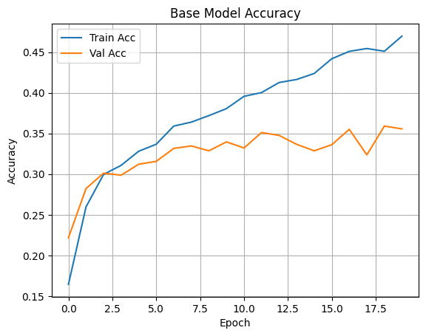Figure 6. Base CNN model Learning Curve per epochs (20 epochs)

**CNN with Dropout and Augmentation Curve**

* **Observation**: The gap between the training and validation curves is smaller, indicating that overfitting is merely reduced. However, the final validation accuracy may still be lower than the baseline’s final validation accuracy.
* **Interpretation**: Regularization and augmentation are preventing the model from overfitting, but possibly also slowing down learning or underfitting the data at the chosen hyperparameters.

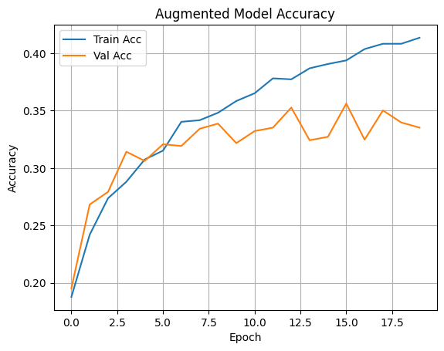Figure 7. Augmented with Dropout CNN model Learning Curve per epochs (20 epochs)

**ResNet50 Transfer Model Curve**

* **Observation**: Both training and validation curves rise quickly and converge with high accuracy (~75–77%) and seeing rapid train accuracy increase from the start to epoch 2nd.
* **Interpretation:**
* Better feature reuse
* Stronger generalization
* Stable learning even without early fine-tuning

Figure 8. ResNet50 Transfer Learning model Learning Curve per epochs (20 epochs)

**2.5 Overfitting Strategies**

To mitigate overfitting, I implemented:

* **Data Augmentation**: Random horizontal flipping, zooming, and rotation increased training data variety.
* **Dropout Layers**: Introduced with 30% and 50% rates after convolution and dense layers respectively.
* **Smaller Model Complexity**: Avoided over-parameterizing the network.

In addition to that, ResNet50 also implicitly prevents overfitting via:

* **Frozen layers** during initial training
* **High-quality pretrained filters** learned from ImageNet
* Preprocessing normalization suited to its original training

**2.6 Testing on Random Images**

To test the model’s generalization, I randomly selected 5 images from the test directory:

random_images = random.sample(os.listdir(test_path), 5)

image_paths = [os.path.join(test_path, img) for img in random_images]

Then, I apply image processing techniques onto it, similar to what I did when training the models, this include convert image to RGB, resize it corresponding to the model’s architectures:

**2.6.1. CNN bases:**

Image size of (128, 128), convert the image to RGB format and NumPy array (to be passed to a model), and normalize pixel values by dividing by 255.

img = Image.open(image_path).convert('RGB')

img = img.resize((128, 128))

img_array = np.array(img) / 255.0

**2.6.2. ResNet base:**

Image size of (224, 224), convert the image to RGB format and NumPy array (to be passed to a model), and normalize pixel values using preprocess_resnet function.

img = Image.open(image_path).convert('RGB')

img = img.resize((224, 224))

img_array = np.array(img)

img_array = preprocess_resnet(img_array)

I have these 5 random selected testing images and the prediction results when running the 3 models:

**Ground Truth**: Insecta

**Result**: Baseline and ResNet50 are correct.

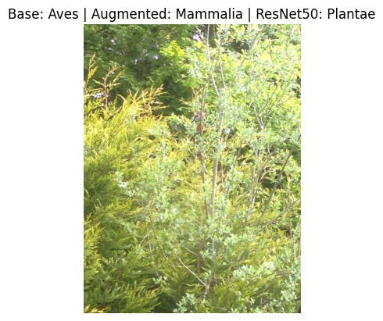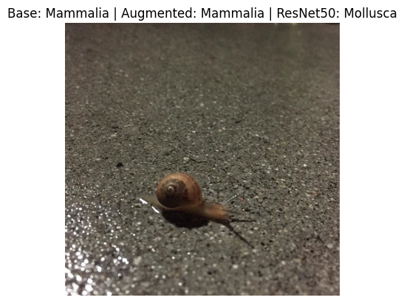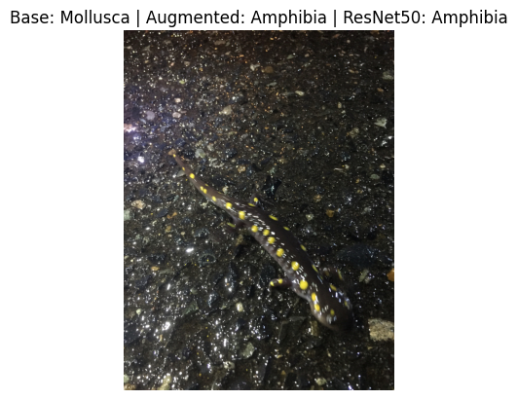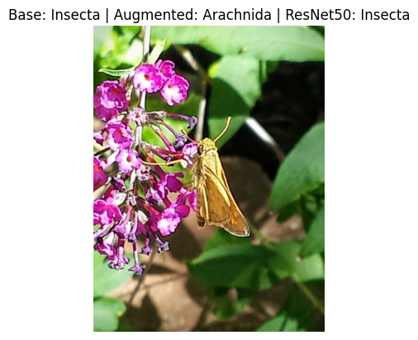

**Ground Truth**: Plantae

**Result**: Only ResNet50 model is correct.

**Ground Truth**: Amphibia

**Result**: Augmented and ResNet50 are correct.

**Ground Truth**: Mollusca

**Result**: Only ResNet50 model is correct.

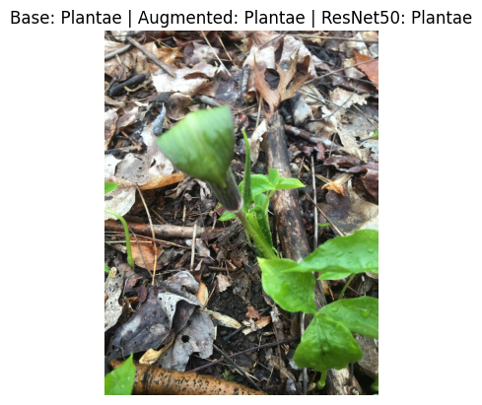

**Ground Truth**: Plantae

**Result**: All models are correct.

* The 5 testing images emphasize the efficiency of ResNet50 model compared to the 2 CNNs.

**Conclusion**

I developed 2 CNN-based models and 1 ResNet50 model with transfer learning, for a 10-class image classification task using Kaggle dataset **"Deep Learning Practice - Image Classification"**. The models were trained and evaluated with two metrics: Top-1 Accuracy and Average Accuracy per Class.

The results showed that **ResNet50 with Transfer Learning** achieved the best performance:

* Top-1 Accuracy: 76.67%
* Average Accuracy per Class: 76.67%

This demonstrates the effectiveness of transfer learning in improving model generalization, particularly when working with limited training data. Future improvements may include fine-tuning top ResNet layers, integrating other pretrained models (e.g., MobileNet, EfficientNet), and extending to multi-label tasks.

Between the 2 CNN-bases, despite regularization and augmentation, the **Baseline** model achieved slightly better results:

* Top-1 Accuracy: 35.56%
* Average Class Accuracy: 35.56%

This suggests room for tuning and further optimization, such as longer training or architectural enhancements.

**Appendix**

* **Tools Used**: TensorFlow/Keras, Scikit-learn, Pandas, Matplotlib
* **Evaluation Metrics**: Top-1 and Average Accuracy, Per-Class Accuracy, Classification Report
* **Data Split**: 80% Training, 20% Validation
* **Hardware**: Google Colab GPU runtime, Google Drive storage

**Accessible URL from shared Google Drive, models saving directory:**

<https://drive.google.com/drive/folders/11Wtq-SJWMlE2vFFNlrfhip4Qt5b8CfvR?usp=sharing>